7.1.14 Editors - 3D View - Header - Mesh - Sculpt mode - Sculpt menu
Sculpt Mode - Sculpt Menu 1
Show All 1
Show Bounding Box 1
Hide Bounding Box 1
Hide Masked 1
Set Pivot 1
Rebuild BVH 1

Sculpt Mode - Sculpt Menu

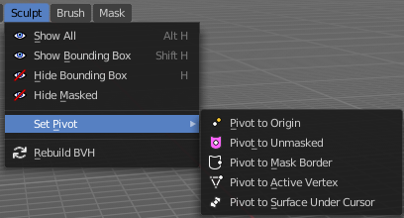
Show All
Makes all invisible mesh parts visible again.

Show Bounding Box
Lets you rectangle select a screen area to make hidden masked parts visible again.

Hide Bounding Box
Lets you rectangle select a screen area to hide mesh parts.

Hide Masked
Hides the masked mesh part.

Set Pivot
Sets the pivot to the chosen location. The menu items should be self explaining. So we don't repeat them here.

Rebuild BVH
Recalculate the sculpt BVH to improve performance.

